GOOGLE PLAY STORE STOLEN MOBILE APPLICATION SCREENING USING DECISION TREE MACHINE LEARNING

ABSTRACT
The increasing number of stolen mobile applications on platforms like the Google Play Store has raised significant concerns regarding security and user privacy. This project aims to address this issue by developing a machine learning-based solution using a Decision Tree classifier to detect and screen potentially stolen or malicious mobile applications. By leveraging a dataset that includes various features such as app permissions, developer information, app categories, and user ratings, the Decision Tree model will be trained to identify patterns indicative of fraudulent or unauthorized applications. The model will classify applications into legitimate or suspicious categories, enhancing the ability to detect apps that could potentially be compromised or stolen, thus improving security for both developers and end-users. This approach provides a scalable and automated solution to monitor and safeguard the Play Store environment from the growing threat of stolen apps, ensuring a safer app ecosystem for mobile users worldwide.
Introduction
The rapid growth of mobile applications on platforms like the Google Play Store has significantly transformed how users interact with their devices. However, this expansion has also led to the emergence of malicious and stolen applications that pose significant risks to both users and developers. These applications often use deceptive tactics to bypass security measures, steal sensitive information, or disrupt the normal functioning of devices. As a result, ensuring the security and authenticity of mobile applications has become a critical challenge for both the Play Store platform and its users.
Detecting stolen or malicious applications on the Play Store requires advanced screening techniques that can analyze large volumes of apps effectively. Traditional methods of manual review are time-consuming, inefficient, and not scalable, given the sheer number of new applications being uploaded every day. To address this issue, machine learning techniques, particularly classification algorithms like Decision Trees, offer a promising solution. These algorithms can automatically detect patterns within a variety of application attributes (e.g., permissions, app behavior, developer reputation) and classify apps as either legitimate or suspicious.
This project aims to develop a decision tree-based model to screen mobile applications for potential theft or malice. By analyzing various features of mobile apps, the system will automatically flag apps that exhibit behavior indicative of being stolen or tampered with, ensuring a safer user experience. The use of machine learning in this context will not only improve detection efficiency but also enhance the overall security of mobile platforms, contributing to a more trustworthy ecosystem for both developers and users.

LITERATURE SURVEY

1. Fraud App Detection of Google Play Store Apps Using Decision Tree
- Developed a model evaluating features such as app ratings, aggregated review scores, in-app purchases, and presence of content additions.
- Compared three classifiers—Decision Tree, Naïve Bayes, and Logistic Regression—and found Decision Tree delivered the best performance (~85% accuracy and high F1-score) WIRED+15IJRASET+15IJRASET+15ResearchGate+1.
- Implementation details are publicly available via a GitHub repository, deployed on a Flask-based web app GitHub.

2. Identifying Fraudulent Apps: Decision Tree + LSTM Hybrid Approach
- A more recent (2025) paper blends Decision Trees for feature importance extraction with LSTM (Long Short-Term Memory) networks to model temporal patterns (e.g. sudden spikes in ratings or downloads).
- Features include permissions, app size, user review sentiment, and behavioral trends.
- The hybrid system shows significant improvements in precision, recall, and F1-score over traditional single-method approaches

3. Identifying Risky Apps: Simple Decision Tree Approach
- Using four core parameters—scaling metrics (like installs), review scores, in-app purchases, and content additions—the Decision Tree classifier provided approximately 85% accuracy in flagging apps as potentially fraudulent

4. Permission-Based Malware Detection in Android
- Earlier static analysis studies used features derived from declared or actually used permissions to train Decision Tree classifiers (often in combination with others) for malware detection.
- For instance, Liu & Liu (2014) built a two-layer permission-based model, relying on lightweight classification first and more detailed static analysis when needed .

5. FairPlay and Multi-modal Approaches
- While not using decision trees, FairPlay and embedding-based methods are relevant:
  - FairPlay leverages review relation patterns, linguistic features, and behavior signals collected over time to distinguish malware and search-rank fraud with over 95% accuracy
  - A multi-modal embedding approach combines image and textual similarity to detect counterfeit apps impersonating legitimate ones, improving precision/recall by 10–25% over baseline methods

PROBLEM STATEMENT
The Google Play Store contains millions of applications, among which many are stolen, cloned, or fraudulent, posing risks such as data theft, privacy violations, and intellectual property infringement. Traditional manual review processes are slow and insufficient to handle the vast number of apps uploaded daily. Existing static detection methods struggle to identify newly emerging fraudulent patterns. There is a critical need for an automated and intelligent screening mechanism that analyzes app metadata, permissions, ratings, and reviews to detect stolen applications. Using a Decision Tree machine learning model can provide accurate classification, reduce false positives, and improve security for users and developers.
Proposed Work
The proposed work aims to develop an intelligent screening system for detecting stolen or fraudulent applications on the Google Play Store using a Decision Tree machine learning model. The system will collect app-related data such as permissions, ratings, number of downloads, reviews, app size, and category. Data preprocessing techniques including feature selection, cleaning, and normalization will be applied to ensure high-quality inputs. A Decision Tree classifier will be trained to identify patterns that distinguish genuine apps from stolen or malicious ones. The model’s performance will be evaluated using accuracy, precision, recall, and F1-score to ensure reliable detection and minimal false positives.
Advantages
- High Interpretability – Decision Trees clearly show how decisions are made, making it easy to understand which features lead to classifying an app as stolen or genuine.
- Fast Processing – Handles large datasets efficiently with low computational complexity.
- Automatic Feature Selection – Identifies the most important features (permissions, ratings, downloads) without manual intervention.
- Handles Mixed Data Types – Works well with both categorical and numerical attributes.
- No Need for Data Normalization – Reduces preprocessing effort.
- Real-Time Screening – Enables quick classification of new apps as legitimate or fraudulent.

SYSTEM ARCHITECTURE
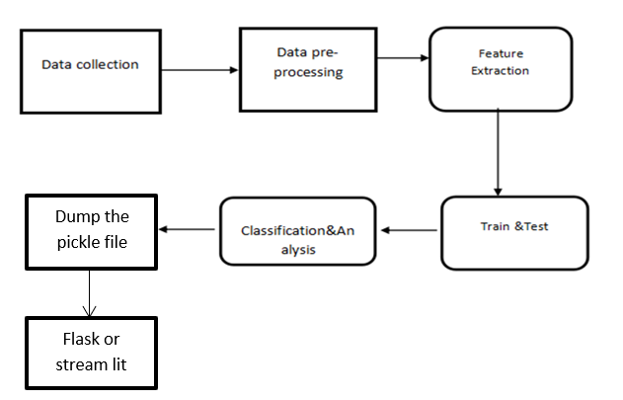

HARDWARE AND SOFTWARE SPECIFICATION
Hardware:
- 1 GB RAM
- 80 GB Hard Disk
- Intel Processor
- LAN
Software :
- Windows OS
- Python GUI or Anaconda Navigator

Algorithms used
● Logistic Regression
● Support Vector Machine
● Random Forest

1. Logistic Regression:
Explanation: Logistic Regression is a linear classification algorithm used for binary or multiclass classification tasks.
Model: Utilizes the logistic function to transform linear predictions into probabilities.
Decision Boundary: Establishes a decision boundary to separate classes in feature space.
Interpretability: Provides interpretable coefficients indicating feature importance.
Assumption: Assumes a linear relationship between features and log-odds of the target.
Regularization: Can include regularization terms to prevent overfitting.
Use Cases: Effective for linearly separable problems, such as spam detection or medical diagnosis.
2. Support Vector Machine (SVM):
Explanation: SVM is a versatile algorithm for classification and regression tasks, aiming to find the optimal hyperplane that separates classes or fits the data well.
Kernel Trick: Can use the kernel trick to transform data into higher-dimensional space, enabling nonlinear decision boundaries.
Margin: Maximizes the margin, the distance between the hyperplane and the nearest data points of each class.
C parameter: Balances the desire for a smooth decision boundary against classifying training points correctly.
Sensitivity to Outliers: SVM can be sensitive to outliers, impacting the position of the optimal hyperplane.
Use Cases: Effective for high-dimensional spaces, image classification, and text categorization.
Multi-class Extension: Supports multi-class classification through methods like one-vs-one or one-vs-all.
3. Random Forest:
Explanation: Random Forest is an ensemble learning method that builds multiple decision trees and merges their predictions for improved accuracy.
Decision Trees: Base models are decision trees, each trained on a random subset of features and data.
Bagging: Employs bagging (bootstrap aggregation) to train each tree on a different bootstrap sample.
Feature Importance: Measures feature importance by assessing how much each feature improves prediction accuracy.
Reducing Overfitting: Combats overfitting by aggregating predictions from diverse trees.
Versatility: Suitable for both classification and regression tasks.
Use Cases: Effective for complex datasets, handling missing values, and achieving high predictive performance.

Implementation Process:

MODULES:
- Data collection
- Data pre-processing
- Feature extraction
- Evaluation

DATA COLLECTION
Data used in this paper is a set of product reviews collected from credit card transactions records. This step is concerned with selecting the subset of all available data that you will be working with. ML problems start with data preferably, lots of data (examples or observations) for which you already know the target answer. Data for which you already know the target answer is called labelled data.

DATA PRE-PROCESSING

Organize your selected data by formatting, cleaning and sampling from it.
Three common data pre-processing steps are:

- Formatting: The data you have selected may not be in a format that is suitable for you to work with. The data may be in a relational database and you would like it in a flat file, or the data may be in a proprietary file format and you would like it in a relational database or a text file.
- Cleaning: Cleaning data is the removal or fixing of missing data. There may be data instances that are incomplete and do not carry the data you believe you need to address the problem. These instances may need to be removed. Additionally, there may be sensitive information in some of the attributes and these attributes may need to be anonymized or removed from the data entirely.
- Sampling: There may be far more selected data available than you need to work with. More data can result in much longer running times for algorithms and larger computational and memory requirements. You can take a smaller representative sample of the selected data that may be much faster for exploring and prototyping solutions before considering the whole dataset.

FEATURE EXTRATION

Next thing is to do Feature extraction is an attribute reduction process. Unlike feature selection, which ranks the existing attributes according to their predictive significance, feature extraction actually transforms the attributes. The transformed attributes, or features, are linear combinations of the original attributes. Finally, our models are trained using Classifier algorithm. We use classify module on Natural Language Toolkit library on Python. We use the labelled dataset gathered. The rest of our labelled data will be used to evaluate the models. Some machine learning algorithms were used to classify pre-processed data. The chosen classifiers were Random forest. These algorithms are very popular in text classification tasks.

EVALUATION MODEL

Model Evaluation is an integral part of the model development process. It helps to find the best model that represents our data and how well the chosen model will work in the future. Evaluating model performance with the data used for training is not acceptable in data science because it can easily generate overoptimistic and over fitted models. There are two methods of evaluating models in data science, Hold-Out and Cross-Validation. To avoid over fitting, both methods use a test set (not seen by the model) to evaluate model performance. Performance of each classification model is estimated base on its averaged. The result will be in the visualized form. Representation of classified data in the form of graphs. Accuracy is defined as the percentage of correct predictions for the test data. It can be calculated easily by dividing the number of correct predictions by the number of total predictions.

Data Flow Diagrams
The abbreviation for Information Stream Outline is DFD. DFD deals with the information flow of a framework or an interaction. Additionally, it provides information on the data sources, outcomes, and actual interactions for each factor. There are no circles, choice criteria, or control streams in DFD. A flowchart can make sense of explicit tasks reliant on the type of data.
It is a graphical tool that makes communicating with clients, supervisors, and other faculty members easier. It is useful for dissecting both the current and the suggested structure.
It provides a summary of the framework procedures for what information there is.
What adjustments are made, what data is archived, what outputs are made, and so on.
There are various ways to address the Information Stream Outline. There are organised investigation exhibiting gadgets at the DFD. Information Stream graphs are well known because they let us visualise the important steps and information involved in programming framework activities.
Four sections make up the information stream graph:

Process Due to dealing capability, a framework's ability to produce change is affected. Images of a conversation may be round, oval, square, or rectangular with rounded corners. The cycle is given a brief name that communicates its essence in a single word or statement.
Information Stream Information stream depicts the data moving between various pieces of the frameworks. The bolt image is the image of information stream. An engaging name ought to be given to the stream to decide the data which is being moved. Information stream additionally addresses material alongside data that is being moved. Material movements are displayed in frameworks that are not simply useful. A given stream ought to just exchange a solitary kind of data. The course of stream is addressed by the bolt which can likewise be bi-directional.
Distribution center The information is put away in the stockroom for sometime in the future. Two flat lines address the image of the store. The distribution center is essentially not confined to being an information record rather it very well may be in any way similar to an envelope with reports, an optical circle, a file organizer. The information distribution center can be seen autonomous of its execution. At the point when the information stream from the stockroom it is considered as information perusing and when information streams to the distribution center it is called information passage or information refreshing.
Eliminator The Eliminator is an outer substance that stands beyond the framework and speaks with the framework. It very well may be, for instance, associations like banks, gatherings like clients or various divisions of a similar association, which isn't a piece of the model framework and is an outside element. Displayed frameworks additionally speak with eliminator.

LEVEL 0
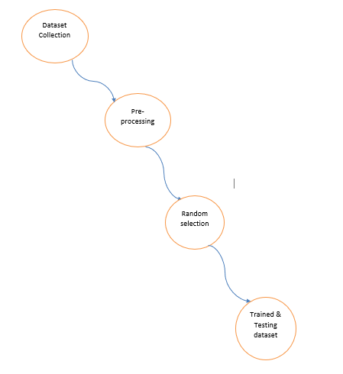

Level1:
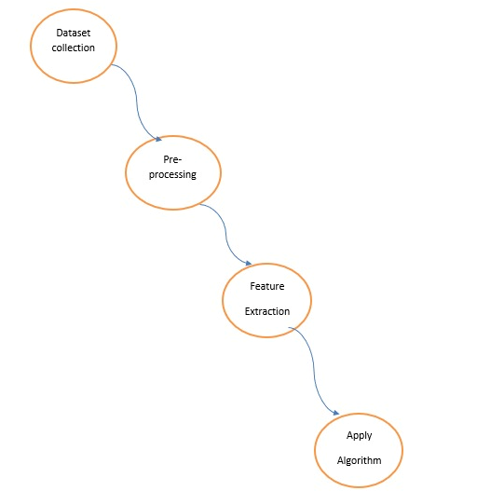

Level2:

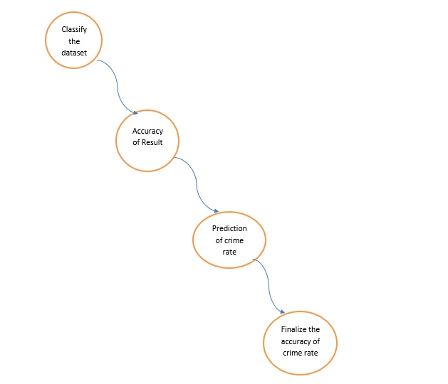

UML DIAGRAMS
The Unified Modeling Language (UML) is used to specify, visualize, modify, construct and document the artifacts of an object-oriented software intensive system under development. UML offers a standard way to visualize a system's architectural blueprints, including elements such as:
- actors
- business processes
- (logical) components
- activities
- programming language statements
- database schemas, and
- Reusable software components.

UML combines best techniques from data modeling (entity relationship diagrams), business modeling (work flows), object modeling, and component modeling. It can be used with all processes, throughout the software development life cycle, and across different implementation technologies. UML has synthesized the notations of the Brooch method, the Object-modeling technique (OMT) and Object-oriented software engineering (OOSE) by fusing them into a single, common and widely usable modeling language. UML aims to be a standard modeling language which can model concurrent and distributed systems.
Sequence Diagram:
Sequence Diagrams Represent the objects participating the interaction horizontally and time vertically. A Use Case is a kind of behavioral classifier that represents a declaration of an offered behavior. Each use case specifies some behavior, possibly including variants that the subject can perform in collaboration with one or more actors. Use cases define the offered behavior of the subject without reference to its internal structure. These behaviors, involving interactions between the actor and the subject, may result in changes to the state of the subject and communications with its environment. A use case can include possible variations of its basic behavior, including exceptional behavior and error handling.
Activity Diagrams-:
Activity diagrams are graphical representations of Workflows of stepwise activities and actions with support for choice, iteration and concurrency. In the Unified Modeling Language, activity diagrams can be used to describe the business and operational step-by-step workflows of components in a system. An activity diagram shows the overall flow of control.

Usecase diagram:
- UML is a standard language for specifying, visualizing, constructing, and documenting the artifacts of software systems.
- UML was created by Object Management Group (OMG) and UML 1.0 specification draft was proposed to the OMG in January 1997.
- OMG is continuously putting effort to make a truly industry standard.
- UML stands for Unified Modeling Language.
- UML is a pictorial language used to make software blue prints

Class diagram
The class diagram is the main building block of object-oriented modeling. It is used for general conceptual modeling of the systematic of the application, and for detailed modeling translating the models into programming code. Class diagrams can also be used for data modeling.[1] The classes in a class diagram represent both the main elements, interactions in the application, and the classes to be programmed.
In the diagram, classes are represented with boxes that contain three compartments:
The top compartment contains the name of the class. It is printed in bold and centered, and the first letter is capitalized.
The middle compartment contains the attributes of the class. They are left-aligned and the first letter is lowercase.
The bottom compartment contains the operations the class can execute. They are also left-aligned and the first letter is lowercase.

Use case Diagram
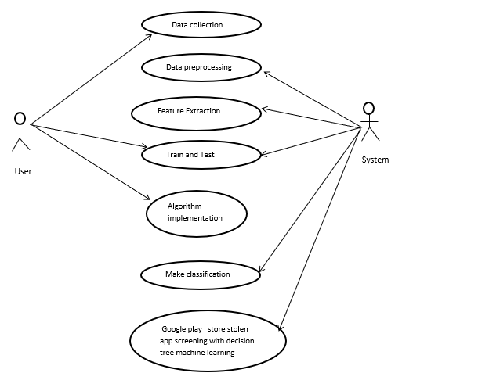

Sequence Diagram:
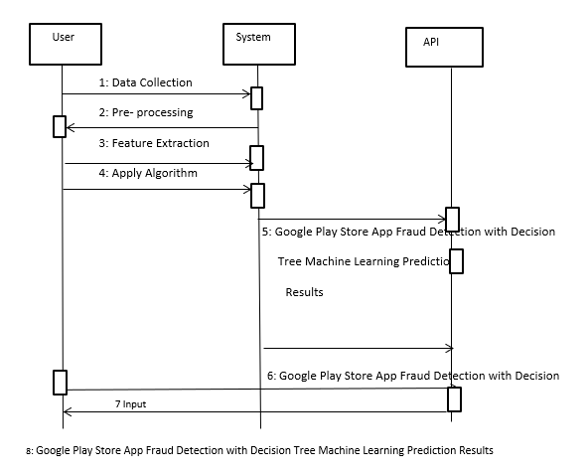

Activity Diagram:

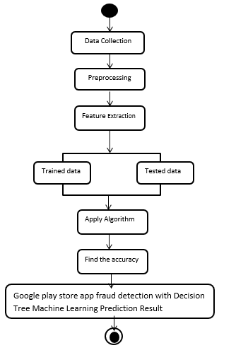

Deployment Diagram
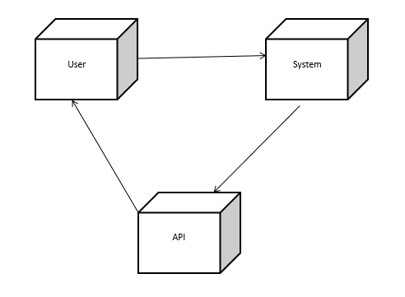

Collaboration Diagram

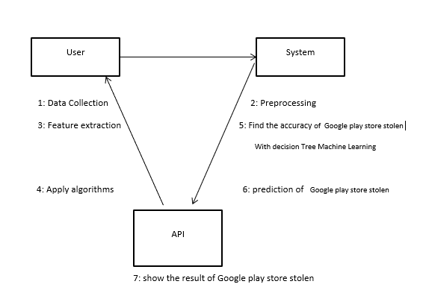

Class Diagram:

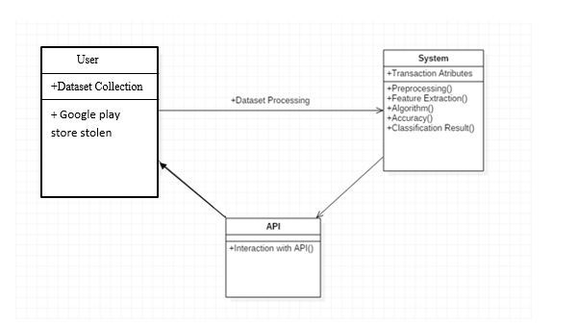
ER Diagram
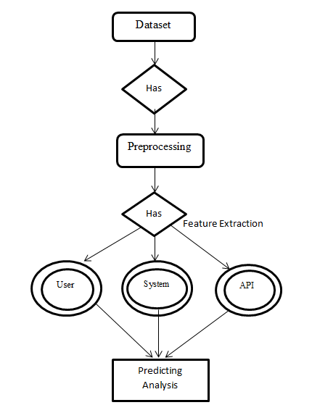

Domain Specification
MACHINE LEARNING
Machine Learning is a system that can learn from example through self-improvement and without being explicitly coded by programmer. The breakthrough comes with the idea that a machine can singularly learn from the data (i.e., example) to produce accurate results.
Machine learning combines data with statistical tools to predict an output. This output is then used by corporate to makes actionable insights. Machine learning is closely related to data mining and Bayesian predictive modeling. The machine receives data as input, use an algorithm to formulate answers.
A typical machine learning tasks are to provide a recommendation. For those who have a Netflix account, all recommendations of movies or series are based on the user's historical data. Tech companies are using unsupervised learning to improve the user experience with personalizing recommendation.
Machine learning is also used for a variety of task like fraud detection, predictive maintenance, portfolio optimization, automatize task and so on.
Machine Learning vs. Traditional Programming
Traditional programming differs significantly from machine learning. In traditional programming, a programmer code all the rules in consultation with an expert in the industry for which software is being developed. Each rule is based on a logical foundation; the machine will execute an output following the logical statement. When the system grows complex, more rules need to be written. It can quickly become unsustainable to maintain.

COMPUTER
DATA RULES

OUTPUT

Machine Learning

How does Machine learning work?
Machine learning is the brain where all the learning takes place. The way the machine learns is similar to the human being. Humans learn from experience. The more we know, the more easily we can predict. By analogy, when we face an unknown situation, the likelihood of success is lower than the known situation. Machines are trained the same. To make an accurate prediction, the machine sees an example. When we give the machine a similar example, it can figure out the outcome. However, like a human, if its feed a previously unseen example, the machine has difficulties to predict.
The core objective of machine learning is the learning and inference. First of all, the machine learns through the discovery of patterns. This discovery is made thanks to the data. One crucial part of the data scientist is to choose carefully which data to provide to the machine. The list of attributes used to solve a problem is called a feature vector. You can think of a feature vector as a subset of data that is used to tackle a problem.
The machine uses some fancy algorithms to simplify the reality and transform this discovery into a model. Therefore, the learning stage is used to describe the data and summarize it into a model.
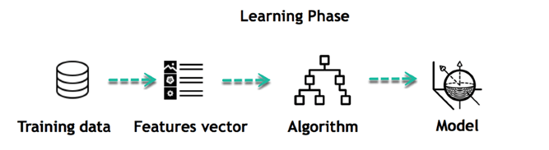
For instance, the machine is trying to understand the relationship between the wage of an individual and the likelihood to go to a fancy restaurant. It turns out the machine finds a positive relationship between wage and going to a high-end restaurant: This is the model
Inferring
When the model is built, it is possible to test how powerful it is on never-seen-before data. The new data are transformed into a features vector, go through the model and give a prediction. This is all the beautiful part of machine learning. There is no need to update the rules or train again the model. You can use the model previously trained to make inference on new data.
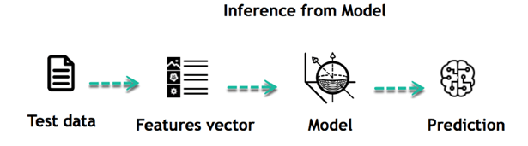
The life of Machine Learning programs is straightforward and can be summarized in the following points:
- Define a question
- Collect data
- Visualize data
- Train algorithm
- Test the Algorithm
- Collect feedback
- Refine the algorithm
- Loop 4-7 until the results are satisfying
- Use the model to make a prediction
Once the algorithm gets good at drawing the right conclusions, it applies that knowledge to new sets of data.
Algorithm Name | Description | Type
Linear regression | Finds a way to correlate each feature to the output to help predict future values. | Regression
Logistic regression | Extension of linear regression that's used for classification tasks. The output variable 3is binary (e.g., only black or white) rather than continuous (e.g., an infinite list of potential colors) | Classification
Decision tree | Highly interpretable classification or regression model that splits data-feature values into branches at decision nodes (e.g., if a feature is a color, each possible color becomes a new branch) until a final decision output is made | Regression Classification
Naive Bayes | The Bayesian method is a classification method that makes use of the Bayesian theorem. The theorem updates the prior knowledge of an event with the independent probability of each feature that can affect the event. | Regression Classification
Support vector machine | Support Vector Machine, or SVM, is typically used for the classification task. SVM algorithm finds a hyperplane that optimally divided the classes. It is best used with a non-linear solver. | Regression (not very common) Classification
Random forest | The algorithm is built upon a decision tree to improve the accuracy drastically. Random forest generates many times simple decision trees and uses the 'majority vote' method to decide on which label to return. For the classification task, the final prediction will be the one with the most vote; while for the regression task, the average prediction of all the trees is the final prediction. | Regression Classification
AdaBoost | Classification or regression technique that uses a multitude of models to come up with a decision but weighs them based on their accuracy in predicting the outcome | Regression Classification
Gradient-boosting trees | Gradient-boosting trees is a state-of-the-art classification/regression technique. It is focusing on the error committed by the previous trees and tries to correct it. | Regression Classification
Machine learning Algorithms and where they are used?
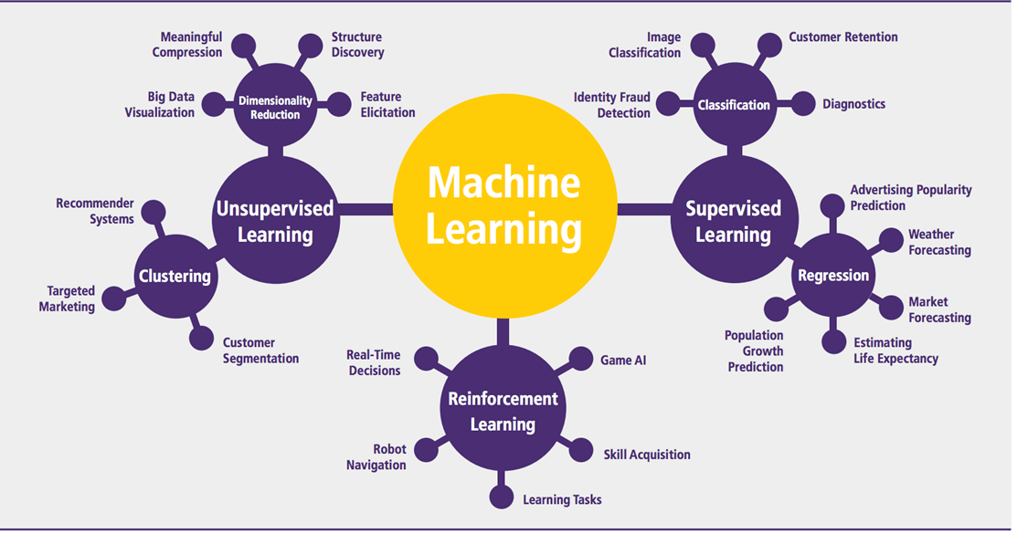
Machine learning can be grouped into two broad learning tasks: Supervised and Unsupervised. There are many other algorithms
Supervised learning
An algorithm uses training data and feedback from humans to learn the relationship of given inputs to a given output. For instance, a practitioner can use marketing expense and weather forecast as input data to predict the sales of cans.
You can use supervised learning when the output data is known. The algorithm will predict new data.
There are two categories of supervised learning:
- Classification task
- Regression task
Classification
Imagine you want to predict the gender of a customer for a commercial. You will start gathering data on the height, weight, job, salary, purchasing basket, etc. from your customer database. You know the gender of each of your customer, it can only be male or female. The objective of the classifier will be to assign a probability of being a male or a female (i.e., the label) based on the information (i.e., features you have collected). When the model learned how to recognize male or female, you can use new data to make a prediction. For instance, you just got new information from an unknown customer, and you want to know if it is a male or female. If the classifier predicts male = 70%, it means the algorithm is sure at 70% that this customer is a male, and 30% it is a female.
The label can be of two or more classes. The above example has only two classes, but if a classifier needs to predict object, it has dozens of classes (e.g., glass, table, shoes, etc. each object represents a class)
Regression
When the output is a continuous value, the task is a regression. For instance, a financial analyst may need to forecast the value of a stock based on a range of feature like equity, previous stock performances, macroeconomics index. The system will be trained to estimate the price of the stocks with the lowest possible error.
Unsupervised learning
In unsupervised learning, an algorithm explores input data without being given an explicit output variable (e.g., explores customer demographic data to identify patterns)
Algorithm | Description | Type
K-means clustering | Puts data into some groups (k) that each contains data with similar characteristics (as determined by the model, not in advance by humans) | Clustering
Gaussian mixture model | A generalization of k-means clustering that provides more flexibility in the size and shape of groups (clusters | Clustering
Hierarchical clustering | Splits clusters along a hierarchical tree to form a classification system.  Can be used for Cluster loyalty-card customer | Clustering
Recommender system | Help to define the relevant data for making a recommendation. | Clustering
PCA/T-SNE | Mostly used to decrease the dimensionality of the data. The algorithms reduce the number of features to 3 or 4 vectors with the highest variances. | Dimension Reduction
You can use it when you do not know how to classify the data, and you want the algorithm to find patterns and classify the data for you

Application of Machine learning
Augmentation:
- Machine learning, which assists humans with their day-to-day tasks, personally or commercially without having complete control of the output. Such machine learning is used in different ways such as Virtual Assistant, Data analysis, software solutions. The primary user is to reduce errors due to human bias.
Automation:
- Machine learning, which works entirely autonomously in any field without the need for any human intervention. For example, robots performing the essential process steps in manufacturing plants.
Finance Industry
- Machine learning is growing in popularity in the finance industry. Banks are mainly using ML to find patterns inside the data but also to prevent fraud.
Government organization
- The government makes use of ML to manage public safety and utilities. Take the example of China with the massive face recognition. The government uses Artificial intelligence to prevent jaywalker.
Healthcare industry
- Healthcare was one of the first industry to use machine learning with image detection.
Marketing
- Broad use of AI is done in marketing thanks to abundant access to data. Before the age of mass data, researchers develop advanced mathematical tools like Bayesian analysis to estimate the value of a customer. With the boom of data, marketing department relies on AI to optimize the customer relationship and marketing campaign.
Example of application of Machine Learning in Supply Chain
Machine learning gives terrific results for visual pattern recognition, opening up many potential applications in physical inspection and maintenance across the entire supply chain network.
Unsupervised learning can quickly search for comparable patterns in the diverse dataset. In turn, the machine can perform quality inspection throughout the logistics hub, shipment with damage and wear.
For instance, IBM's Watson platform can determine shipping container damage. Watson combines visual and systems-based data to track, report and make recommendations in real-time.
In past year stock manager relies extensively on the primary method to evaluate and forecast the inventory. When combining big data and machine learning, better forecasting techniques have been implemented (an improvement of 20 to 30 % over traditional forecasting tools). In term of sales, it means an increase of 2 to 3 % due to the potential reduction in inventory costs.
Example of Machine Learning Google Car
For example, everybody knows the Google car. The car is full of lasers on the roof which are telling it where it is regarding the surrounding area. It has radar in the front, which is informing the car of the speed and motion of all the cars around it. It uses all of that data to figure out not only how to drive the car but also to figure out and predict what potential drivers around the car are going to do. What's impressive is that the car is processing almost a gigabyte a second of data.

Deep Learning
Deep learning is a computer software that mimics the network of neurons in a brain. It is a subset of machine learning and is called deep learning because it makes use of deep neural networks. The machine uses different layers to learn from the data. The depth of the model is represented by the number of layers in the model. Deep learning is the new state of the art in term of AI. In deep learning, the learning phase is done through a neural network.
Reinforcement Learning
Reinforcement learning is a subfield of machine learning in which systems are trained by receiving virtual "rewards" or "punishments," essentially learning by trial and error. Google's DeepMind has used reinforcement learning to beat a human champion in the Go games. Reinforcement learning is also used in video games to improve the gaming experience by providing smarter bot.
One of the most famous algorithms are:
- Q-learning
- Deep Q network
- State-Action-Reward-State-Action (SARSA)
- Deep Deterministic Policy Gradient (DDPG)
Applications/ Examples of deep learning applications
AI in Finance: The financial technology sector has already started using AI to save time, reduce costs, and add value. Deep learning is changing the lending industry by using more robust credit scoring. Credit decision-makers can use AI for robust credit lending applications to achieve faster, more accurate risk assessment, using machine intelligence to factor in the character and capacity of applicants.
Underwrite is a Fintech company providing an AI solution for credit makers company. underwrite.ai uses AI to detect which applicant is more likely to pay back a loan. Their approach radically outperforms traditional methods.
AI in HR: Under Armour, a sportswear company revolutionizes hiring and modernizes the candidate experience with the help of AI. In fact, Under Armour Reduces hiring time for its retail stores by 35%. Under Armour faced a growing popularity interest back in 2012. They had, on average, 30000 resumes a month. Reading all of those applications and begin to start the screening and interview process was taking too long. The lengthy process to get people hired and on-boarded impacted Under Armour's ability to have their retail stores fully staffed, ramped and ready to operate.
At that time, Under Armour had all of the 'must have' HR technology in place such as transactional solutions for sourcing, applying, tracking and onboarding but those tools weren't useful enough. Under armour choose HireVue, an AI provider for HR solution, for both on-demand and live interviews. The results were bluffing; they managed to decrease by 35% the time to fill. In return, the hired higher quality staffs.

AI in Marketing: AI is a valuable tool for customer service management and personalization challenges. Improved speech recognition in call-center management and call routing as a result of the application of AI techniques allows a more seamless experience for customers.
For example, deep-learning analysis of audio allows systems to assess a customer's emotional tone. If the customer is responding poorly to the AI chatbot, the system can be rerouted the conversation to real, human operators that take over the issue.
Apart from the three examples above, AI is widely used in other sectors/industries.
Artificial Intelligence
Machine Learning
Deep Learning

Difference between Machine Learning and Deep Learning
 | Machine Learning | Deep Learning
Data Dependencies | Excellent performances on a small/medium dataset | Excellent performance on a big dataset
Hardware dependencies | Work on a low-end machine. | Requires powerful machine, preferably with GPU: DL performs a significant amount of matrix multiplication
Feature engineering | Need to understand the features that represent the data | No need to understand the best feature that represents the data
Execution time | From few minutes to hours | Up to weeks. Neural Network needs to compute a significant number of weights
Interpretability | Some algorithms are easy to interpret (logistic, decision tree), some are almost impossible (SVM, XGBoost) | Difficult to impossible

When to use ML or DL?
In the table below, we summarize the difference between machine learning and deep learning.
 | Machine learning | Deep learning
Training dataset | Small | Large
Choose features | Yes | No
Number of algorithms | Many | Few
Training time | Short | Long
With machine learning, you need fewer data to train the algorithm than deep learning. Deep learning requires an extensive and diverse set of data to identify the underlying structure. Besides, machine learning provides a faster-trained model. Most advanced deep learning architecture can take days to a week to train. The advantage of deep learning over machine learning is it is highly accurate. You do not need to understand what features are the best representation of the data; the neural network learned how to select critical features. In machine learning, you need to choose for yourself what features to include in the model.
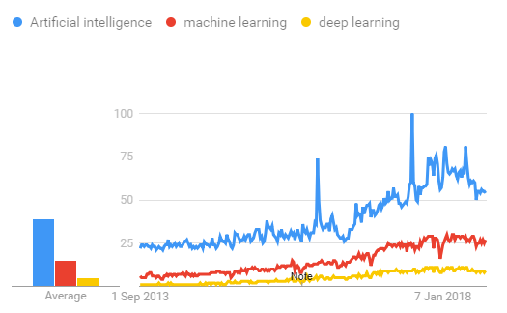
TensorFlow
the most famous deep learning library in the world is Google's TensorFlow. Google product uses machine learning in all of its products to improve the search engine, translation, image captioning or recommendations.
To give a concrete example, Google users can experience a faster and more refined the search with AI. If the user types a keyword a the search bar, Google provides a recommendation about what could be the next word.
Google wants to use machine learning to take advantage of their massive datasets to give users the best experience. Three different groups use machine learning:
- Researchers
- Data scientists
- Programmers.
They can all use the same toolset to collaborate with each other and improve their efficiency.
Google does not just have any data; they have the world's most massive computer, so TensorFlow was built to scale. TensorFlow is a library developed by the Google Brain Team to accelerate machine learning and deep neural network research.
It was built to run on multiple CPUs or GPUs and even mobile operating systems, and it has several wrappers in several languages like Python, C++ or Java.
In this tutorial, you will learn
TensorFlow Architecture
Tensor flow architecture works in three parts:
- Pre processing the data
- Build the model
- Train and estimate the model
It is called Tensor flow because it takes input as a multi-dimensional array, also known as tensors. You can construct a sort of flowchart of operations (called a Graph) that you want to perform on that input. The input goes in at one end, and then it flows through this system of multiple operations and comes out the other end as output.
This is why it is called TensorFlow because the tensor goes in it flows through a list of operations, and then it comes out the other side.
Where can Tensor flow run?
TensorFlow can hardware, and software requirements can be classified into
Development Phase: This is when you train the mode. Training is usually done on your Desktop or laptop.
Run Phase or Inference Phase: Once training is done Tensorflow can be run on many different platforms. You can run it on
- Desktop running Windows, macOS or Linux
- Cloud as a web service
- Mobile devices like iOS and Android
You can train it on multiple machines then you can run it on a different machine, once you have the trained model.
The model can be trained and used on GPUs as well as CPUs. GPUs were initially designed for video games. In late 2010, Stanford researchers found that GPU was also very good at matrix operations and algebra so that it makes them very fast for doing these kinds of calculations. Deep learning relies on a lot of matrix multiplication. TensorFlow is very fast at computing the matrix multiplication because it is written in C++. Although it is implemented in C++, TensorFlow can be accessed and controlled by other languages mainly, Python.
Finally, a significant feature of Tensor Flow is the Tensor Board. The Tensor Board enables to monitor graphically and visually what TensorFlow is doing.
List of Prominent Algorithms supported by TensorFlow
- Linear regression: tf. estimator .Linear Regressor
- Classification :tf. Estimator .Linear Classifier
- Deep learning classification: tf. estimator. DNN Classifier
- Booster tree regression: tf.estimator.BoostedTreesRegressor
- Boosted tree classification: tf.estimator.BoostedTreesClassifier

PYTHON OVERVIEW
Python is a high-level, interpreted, interactive and object-oriented scripting language. Python is designed to be highly readable. It uses English keywords frequently where as other languages use punctuation, and it has fewer syntactical constructions than other languages.

- Python is Interpreted: Python is processed at runtime by the interpreter. You do not need to compile your program before executing it. This is similar to PERL and PHP.

- Python is Interactive: You can actually sit at a Python prompt and interact with the interpreter directly to write your programs.

- Python is Object-Oriented: Python supports Object-Oriented style or technique of programming that encapsulates code within objects.

- Python is a Beginner's Language: Python is a great language for the beginner-level programmers and supports the development of a wide range of applications from simple text processing to WWW browsers to games.

History of Python

Python was developed by Guido van Rossum in the late eighties and early nineties at the National Research Institute for Mathematics and Computer Science in the Netherlands.

Python is derived from many other languages, including ABC, Modula-3, C, C++, Algol-68, SmallTalk, Unix shell, and other scripting languages.

Python is copyrighted. Like Perl, Python source code is now available under the GNU General Public License (GPL).

Python is now maintained by a core development team at the institute, although Guido van Rossum still holds a vital role in directing its progress.

Python Features
Python's features include:

Easy-to-learn: Python has few keywords, simple structure, and a clearly defined syntax. This allows the student to pick up the language quickly.

Easy-to-read: Python code is more clearly defined and visible to the eyes.

Easy-to-maintain: Python's source code is fairly easy-to-maintain.

A broad standard library: Python's bulk of the library is very portable and cross-platform compatible on UNIX, Windows, and Macintosh.

Interactive Mode: Python has support for an interactive mode which allows interactive testing and debugging of snippets of code.

Portable: Python can run on a wide variety of hardware platforms and has the same interface on all platforms.

Extendable: You can add low-level modules to the Python interpreter. These modules enable programmers to add to or customize their tools to be more efficient.

Databases: Python provides interfaces to all major commercial databases.

GUI Programming: Python supports GUI applications that can be created and ported to many system calls, libraries, and windows systems, such as Windows MFC, Macintosh, and the X Window system of Unix.

Scalable: Python provides a better structure and support for large programs than shell scripting.

Apart from the above-mentioned features, Python has a big list of good features, few are listed below:

- IT supports functional and structured programming methods as well as OOP.

- It can be used as a scripting language or can be compiled to byte-code for building large applications.

- It provides very high-level dynamic data types and supports dynamic type checking.

- IT supports automatic garbage collection.

- It can be easily integrated with C, C++, COM, ActiveX, CORBA, and Java.

Python is available on a wide variety of platforms including Linux and Mac OS X. Let's understand how to set up our Python environment.

ANACONDA NAVIGATOR
Anaconda Navigator is a desktop graphical user interface (GUI) included in Anaconda distribution that allows you to launch applications and easily manage conda packages, environments and channels without using command-line commands. Navigator can search for packages on Anaconda Cloud or in a local Anaconda Repository. It is available for Windows, mac OS and Linux.
Why use Navigator?
In order to run, many scientific packages depend on specific versions of other packages. Data scientists often use multiple versions of many packages, and use multiple environments to separate these different versions.
The command line program conda is both a package manager and an environment manager, to help data scientists ensure that each version of each package has all the dependencies it requires and works correctly.
Navigator is an easy, point-and-click way to work with packages and environments without needing to type conda commands in a terminal window. You can use it to find the packages you want, install them in an environment, run the packages and update them, all inside Navigator.
WHAT APPLICATIONS CAN I ACCESS USING NAVIGATOR?
The following applications are available by default in Navigator:
- Jupyter Lab
- Jupyter Notebook
- QT Console
- Spyder
- VS Code
- Glue viz
- Orange 3 App
- Rodeo
- RStudio
Advanced conda users can also build your own Navigator applications
How can I run code with Navigator?
The simplest way is with Spyder. From the Navigator Home tab, click Spyder, and write and execute your code.
You can also use Jupyter Notebooks the same way. Jupyter Notebooks are an increasingly popular system that combine your code, descriptive text, output, images and interactive interfaces into a single notebook file that is edited, viewed and used in a web browser.
What’s new in 1.9?
- Add support for Offline Mode for all environment related actions.
- Add support for custom configuration of main windows links.
- Numerous bug fixes and performance enhancements.

ASSESSMENT MODEL
Model The method involved with fostering a model incorporates assessment. Finding the model that best portrays our information and predicts how well the model will act in what's to come is useful. In information science, it isn't adequate to assess model execution utilizing the preparation information since this can rapidly prompt excessively hopeful and overfitted models. Wait and Cross-Approval are two procedures utilized in information science to evaluate models.
The two methodologies utilize a test set (concealed by the model) to survey model execution to forestall over fitting. In light of its normal, every classification model's presentation is assessed. The result will take on the structure that was envisioned. diagram portrayal of information that has been ordered.
Accuracy: The level of precise expectations for the test information is implied by precision. By partitioning the quantity of exact expectations by the complete number of forecasts, it very well might still up in the air.
Python Libraries
Python provides a variety of GUI (Graphical User Interface) creation options. Tkinter is the most frequently used GUI method out of all of them. It is a typical Python connection point to the Python distribution's Tk GUI tool stack. The quickest and easiest way to create GUI apps is with Python and Tkinter. Tkinter makes creating a GUI an easy task.
A tkinter application can be created by:

introducing the tkinter module
Create the basic window (holder)
Add a lot of devices to the main window.
Apply the event Trigger to the devices.
Tkinter can be inserted into the Python code just like any other module.
Note that the module's name changes from "Tkinter" in Python 2.x to "tkinter" in Python 3.x.

bring up tkinter
When creating a Python application with a GUI, the client needs to keep in mind two main strategies that are used.

Tk(screenName = 'None', base = 'None', class = 'Tk', useTk = 1):
Tkinter provides the method 'Tk(screenName=None, baseName=None, className='Tk', useTk=1)' to create a main window.
You can alter the className to the desired one to change the window's name. The primary code used to create the application's main window is m=tkinter.Tk(), mainloop(), where m is the name of the basic window object
When your application is ready to run, a technique called as mainloop() is used.
As long as the window is open, the application will run indefinitely throughout the mainloop() loop, which is used to anticipate events and respond to them.
m.mainloop()tikinter

Additionally, tkinter provides access to the mathematical configuration of the devices that can arrange the devices in the parent windows. Fundamentally, there are three main maths classes.
Pack() technique:Prior to inserting the parent device, it organises the devices into blocks.
matrix() technique:Before setting in the parent gadget, it networks the devices together (in a table-like form).
place() technique:It organises the devices by positioning them in clear positions decided upon by the software programmer.

You can include a variety of tools in your tkinter application.

Button: This gadget is used to add a button to your programme.
w=Button(master, option=value) is the general grammar, and ace is the boundary used to refer to the parent window.
The arrangement of the Buttons can be changed using a variety of options. Choices can be passed as boundaries that are separated by commas. The list below includes a few of them.

To set the background tone when the button is under the cursor, use activebackground.
When a button is under the cursor, the activeforeground setting sets the forefront tone.
bg: to establish the standard foundational tone.
to call a capability is the order.
textual style: to change the button mark's text style.
image: to place an image on a button.
width: to modify the button's width.
level: to modify the button's level.

NumPy:
The free source Python package NumPy (Mathematical Python) is used in virtually every field of science and design. It serves as the foundation of the logical Python and PyData environments and is the standard practise for working with mathematical data in Python. Clients of NumPy range from novice programmers to seasoned analysts performing top-tier logical and cutting-edge inventive work. Numerous information scientific and logical Python bundles, including Pandas, SciPy, Matplotlib, scikit-learn, and scikit-picture, make extensive use of the NumPy Programming interface. Complex network and exhibit information structures are available in the NumPy library (you'll find out more information about this in later sections). It offers ways to successfully work on ndarray, a homogenous n-layered cluster object.
Numerous numerical operations can be played out on exhibitions using NumPy. It provides a vast library of high level numerical capabilities that are compatible with these displays and frameworks, as well as powerful information designs that are added to Python that assure accurate estimations with clusters and lattices.

NumPy is introduced here: pip introduce numpy
Import Numpy as np is how to do it.

The NumPy library's exhibit is its main information design. A matrix of numbers that serves as an exhibit comprises information on the raw data, how to locate a component, and how to interpret a component. It is made up of a lattice of parts that can be filed in various ways.
The components can be expressed as whole numbers, booleans, another exhibit, or analogous types of nonnegative numbers. The number of factors determines where the cluster is located. A tuple of numbers indicating the size of the exhibit along each axis makes up the cluster's state.
Pandas: The cluster dtype is hinted at.
A tuple of pandas, a Python library that provides rapid, adaptive, and expressive information structures designed to enable working with "social" or "marked" information simple and natural, can be filed into a cluster. It intends to serve as the primary major level building piece for conducting practical, accurate information analysis in Python.
Additionally, it aspires to become the most remarkable and flexible open source information examination/control tool obtainable in any language. It has already made significant progress in achieving this goal.
Primary Components
Size variability: portions can be inserted in and erased from DataFrame and higher layered objects Simple treatment of missing information (addressed as NaN, NA, or NaT) in drifting point information as well as non-drifting point information
Programmed and explicit information organisation: Items can be explicitly changed to a group of names, or the client can merely ignore the markings and let Series, DataFrame, and other similar entities subsequently alter the information for calculations.
Make it simple to convert battered, unexpectedly listed information in other Python and NumPy information structures into DataFrame objects. Strong, adaptable collection by usefulness to perform split-apply-join procedure on informational collections, for both aggregating and changing information.
Pip intall pandas

Matplotlib:
A remarkable Python representation library for 2D cluster plots is Matplotlib. Based on NumPy clusters, Matplotlib is a multi-stage information perception library designed to operate with the more comprehensive SciPy stack. In the year 2002, John Tracker delivered the speech. The ability to visually access vast amounts of information in delicious pictures is one of perception's biggest benefits. Several plots, including line, bar, scatter, histogram, and others, are included in Matplotlib. Matplotlib and the great majority of its conditions are available as wheel bundles for Windows, Linux, and macOS.

Matplotlib is introduced in the establishment phase of pip.

Run the supplemental command to launch the matplotlib bundle:

matplotlib - mpip introduction - python

Many different types of graphs are supported by Matplotlib. Plots help with creating relationships, patterns, and designs. They are typically tools for considering quantitative data.

Seaborn:
A matplotlib-based information perception library called Seaborn is tightly integrated with Python's pandas data structures. The main component of Seaborn is perception, which aids in information research and comprehension. To learn about Seaborn, one needs be knowledgeable in Numpy, Matplotlib, and Pandas.
Seaborn provides the following features:
Programming interface with a dataset to determine the relationships between variables.
Straight relapse plots are assessed and plotted using a programme.
For multi-plot frameworks, it supports important level debates.
Imagining the dispersion of univariate and bivariate data.
The procedure used to establish the Seaborn library is as follows:

sns import seaborn
Here are a handful of well-known plotting libraries to get an outline:
- Matplotlib: accessible and full of opportunities
2. Pandas Perception is a user-friendly interface built on Matplotlib.
3. Seaborn: outstanding default styles, important level connection point
4.ggplot: makes use of the Syntax of Illustrations in R's ggplot2
5.Plotly: able to create clever plots
In this post, we'll learn how to use Matplotlib, Pandas Perception, and Seaborn to create basic plots and how to make use of a few specific features from each library. Instead of attempting to interpret the schematics, this essay will focus just on the punctuation.

Matplotlib
Matplotlib is the most famous python plotting library. It is a low level library with a Matlab like point of interaction which offers heaps of opportunity at the expense of composing more code.
1.To introduce Matplotlib pip and conda can be utilized.
2.pip introduce matplotlib
3.conda introduce matplotlib
Matplotlib is explicitly really great for making essential diagrams like line outlines, bar graphs, histograms and some more. It very well may imported by type:
●import matplotlib.pyplot as plt

Line Outline
In Matplotlib we can make a line outline by calling the plot strategy. We can likewise plot different sections in a single diagram, by circling through the segments we need, and plotting every section on a similar hub.
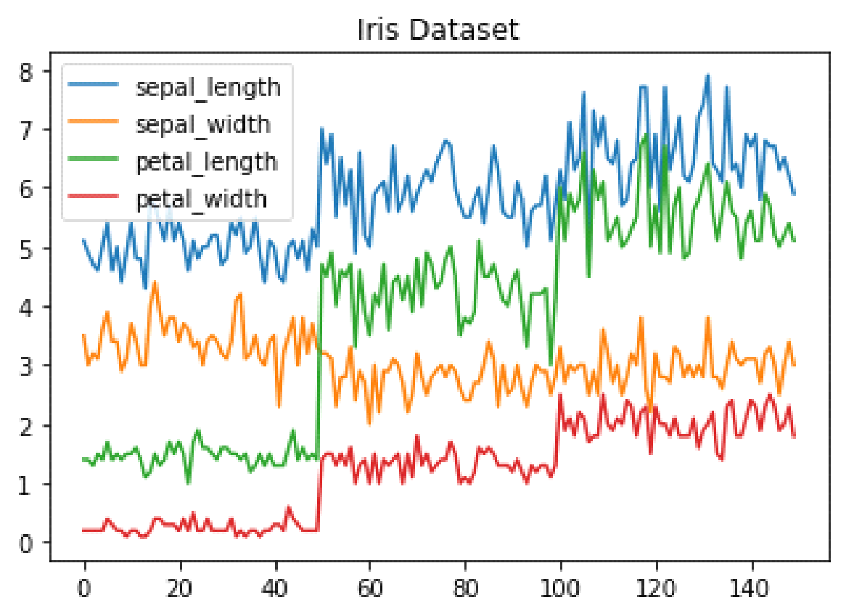
Line Chart
Histogram
In Matplotlib we can make a Histogram utilizing the hist technique. Assuming that we pass it downright information like the focuses segment from the wine-survey dataset it will naturally ascertain how frequently each class happens.
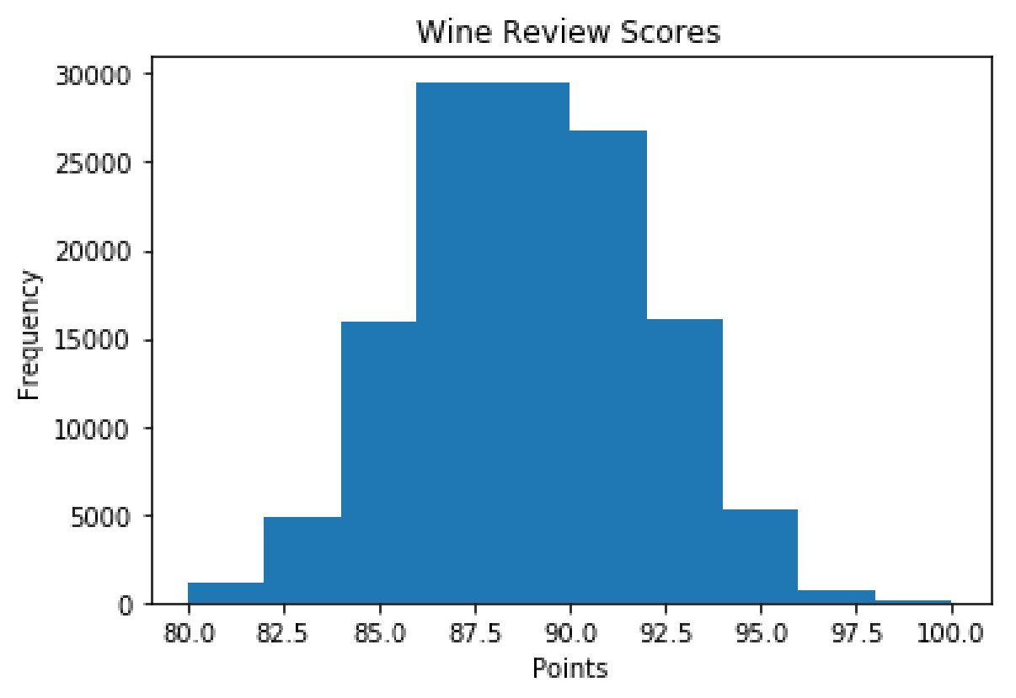
Fig. Histogram
Bar Diagram
A bar-diagram can be made utilizing the bar strategy. The bar-outline isn't consequently computing the recurrence of a classification so we will utilize pandas value_counts capability to do this. The bar-outline is valuable for downright information that has relatively little various classifications (under 30) in light of the fact that else it can get very chaotic.

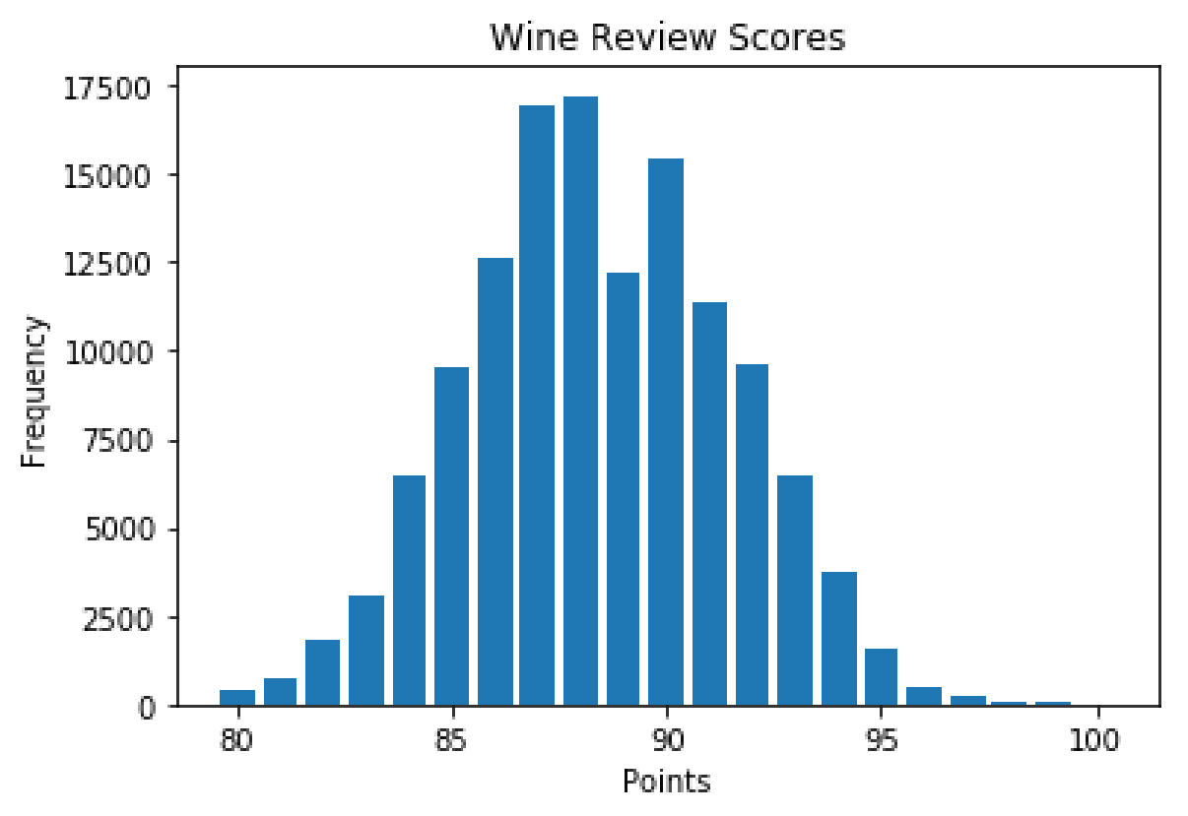
Bar-Chart

Pandas Visualization
Pandas is an open source superior execution, simple to-utilize library giving information structures, for example, dataframes, and information examination devices like the representation instruments we will use in this article.
Pandas Perception makes it truly simple to make plots out of a pandas dataframe and series. It likewise has a more elevated level Programming interface than Matplotlib and hence we want less code for similar outcomes.
●Pandas can be introduced utilizing either pip or conda.
●pip introduce pandas
●conda introduce pandas
Heatmap
A Heatmap is a graphical portrayal of information where the singular qualities contained in a lattice are addressed as varieties. Heatmaps are ideally suited for investigating the connection of elements in a dataset.
To get the relationship of the highlights inside a dataset we can call <dataset>.corr() , which is a Pandas dataframe strategy. This will give utilize the connection grid.
We can now utilize either Matplotlib or Seaborn to make the heatmap.
Matplotlib:
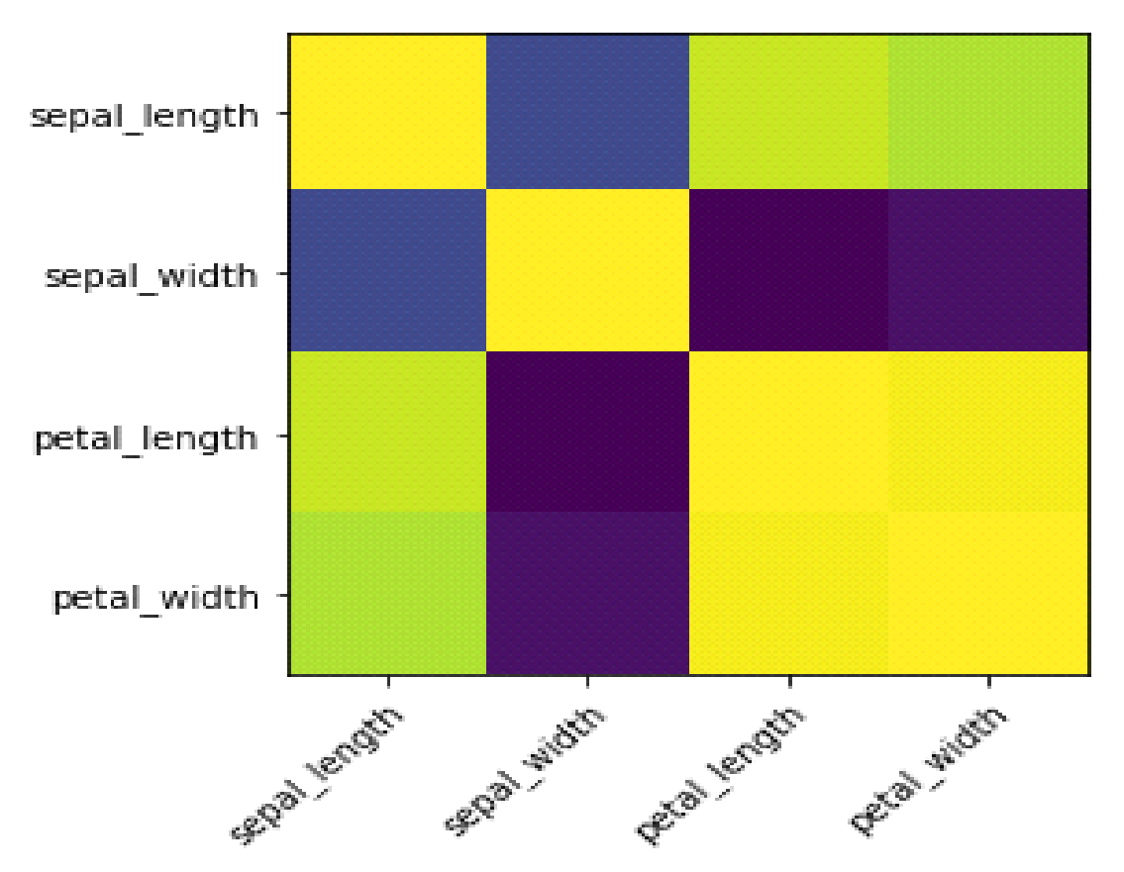
Heatmap without annotations
Information perception is the discipline of attempting to comprehend information by setting it in a visual setting, so that examples, patterns and relationships that could not in any case be recognized can be uncovered.
Python offers various incredible diagramming libraries that come loaded with bunches of various highlights. In this article we checked out at Matplotlib, Pandas representation and Seaborn.
Scikit-learn:
Scikit-learn is an open source information examination library, and the best quality level for AI (ML) in the Python biological system
Ideas And Highlights:
Characterization: distinguishing and ordering information in light of examples
Relapse: anticipating or projecting information values in light of the typical mean of existing and arranged information.
Bunching: programmed gathering of comparable information into datasets.
Calculations that help prescient investigation going from basic straight relapse to brain network design acknowledgment.
Interoperability with NumPy, pandas, and matplotlib libraries.
ML is an innovation that empowers PCs to gain from input information and to fabricate/train a prescient model without unequivocal programming. ML is a subset of Man-made consciousness (simulated intelligence).
Whether you are only searching for a prologue to ML, need to make ready quick, or are searching for the most recent ML research instrument, you will find that scikit-learn is both factual and simple to learn/use. As a significant level library, it allows you to characterize a prescient information model in only a couple of lines of code, and afterward utilize that model to accommodate your information. It's adaptable and coordinates well with other Python libraries, for example, matplotlib for plotting, numpy for cluster vectorization, and pandas for information outlines

TESTING
Programming testing is an examination directed to furnish partners with data about the nature of the item or administration under test. Programming Testing additionally gives a goal, free perspective on the product to permit the business to appreciate and figure out the dangers at execution of the product. Test procedures incorporate, however are not restricted to, the most common way of executing a program or application with the plan of finding programming bugs.
Programming Testing can likewise be expressed as the method involved with approving and confirming that a product program/application/item:
●Meets the business and specialized prerequisites that directed its plan and Improvement.
●Fills in true to form and can be executed with similar qualities.
TESTING Techniques

Utilitarian tests give deliberate exhibitions that capabilities tried are accessible as determined by the business and specialized necessities, framework documentation, and client manuals.
Useful testing is focused on the accompanying things:
●Capabilities: Recognized capabilities should be worked out.
●Yield: Distinguished classes of programming yields should be worked out.
●Frameworks/Strategies: framework ought to work appropriately

Combination Testing

Programming combination testing is the steady coordination testing of at least two incorporated programming parts on a solitary stage to deliver disappointments brought about by interface surrenders.

Experiment for Succeed Sheet Check:

Here in AI we are managing dataset which is in succeed sheet design so assuming that any experiment we really want implies we really want to check succeed document. Later on order will deal with the particular segments of dataset .
Test Case 1 :

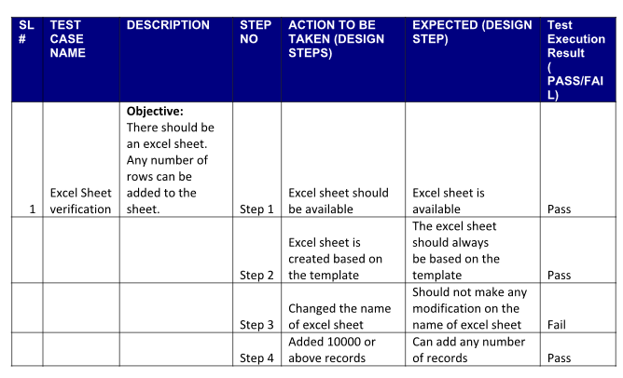

Conclusion:
Predicting power consumption based on home areas using machine learning (ML) offers a valuable solution for optimizing energy usage. By leveraging ML algorithms, such as regression models or neural networks, we can analyze historical data from diverse home areas to establish patterns and make accurate consumption forecasts. These models consider various factors like the size of homes, geographical location, and appliance usage, enabling a nuanced prediction of power consumption. The insights derived from ML-powered predictions can guide homeowners, utility providers, and policymakers in implementing efficient energy management strategies. This not only enhances the sustainability of energy consumption but also contributes to cost savings and environmental conservation. In conclusion, ML-driven power consumption prediction in home areas is a powerful tool for fostering energy efficiency, informed decision-making, and a more sustainable future.
Future Enhancement:
Smart Appliance Integration:
Explanation: Enhance the power consumption prediction model by integrating data from smart appliances and IoT devices within homes. This allows for a more granular analysis of individual devices' energy usage patterns, contributing to a more accurate and detailed prediction of overall power consumption.
Incorporation of Socio-Economic Factors:
Explanation: Integrate socio-economic data such as household income, family size, and employment status to capture the influence of these factors on energy consumption behaviors. This inclusion will provide a holistic understanding of the social context, enabling the model to offer more tailored predictions that align with residents' lifestyles.
Renewable Energy Source Integration:
Explanation: Extend the model's capability by incorporating information on renewable energy sources, weather conditions, and local energy production. This enhancement allows for predictions that not only consider consumption but also factor in the potential impact of renewable energy adoption and environmental conditions on the overall power grid.
References:
[I] C. M. Bishop.: Newral Networks for Pattern Recognition. Oxford University Press, 1995.
[2] W. Hart.: Non-intrusive appliance load monitoring. Proceedings of the IEEE, vol. 80, no. 12, 1992.
[3] J.Moody et al.: Fast learning in networks of locallytuned processing units. Neural Computation 1 (2), , 692498, 2001. 281-294, 1989.
[4] H.Murata et al.: Applying Kernel Based Subspace classification to a Non-Intrusive Monitoring System for Household Electric Appliances. ICANN2001
[5] T.Onoda et al.: Applying Support Vector Machines and Boosting to a Non-Intrusive Monitoring System for Household Electric Appliances with Inverters. NC'2000, 2000.
[6] D. E. Rumelhart et al.: Learning Internal Rep resent ations by Error Propagation. Parallel Distributed Processing: Explorations in the Microstructure of Cognition, Vol. l: Foundations, 318-362, Bradford Books/MIT Press, Cambridge, MA., 1986.
[7] V. N. Vapnik.: The Nature of Statistical Learning TheonJ. Springer, 1995.

